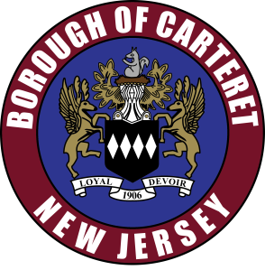

**Borough of Carteret**

61 Cooke Avenue

Carteret, New Jersey 07008

Tel: (732) 541-3936

Borough of Carteret Zoning Board of Adjustment Meeting Notice

The Zoning Board of Adjustment for the Borough of Carteret will be administered via video conference on January 21, 2025 at 6:00 p.m. with link https://carteret.my.webex.com/carteret.my/j.php?MTID=m7d87e87bc8e4d58a726b9f1a6e442d42 access code 2557 106 0687 password 07008 and call-in 415-655-0001. For any further questions please reach out to the Board Secretary, Lauren Curran, at 732-541-3801 or CurranL@carteret.net

All agenda items including site plans and exhibits will be available on www.carteret.net.

-Carteret Zoning Board of Adjustment

lsc